***Mrs. Greene’s December Newsletter 2024***

Parent this month we are learning how to catch different things and items with the help of the authors of the book series “How to Catch A…”.

**E.L.A.: This month we will continue our weekly spelling words.**

**Students will also begin identifying story elements using drawings and writing responses to reading to show what happened in the beginning, middle and end of a story.**

**We are going to start adding adjective to our sentences. Be very descriptive.**

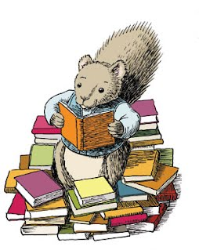

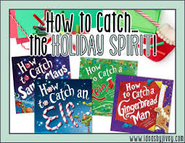

**Celebrate the Holiday Season: Students will observe different holiday traditions around the United States (Christmas, Hanukkah, Kwanzaa).**



**Join us as we sing our hearts out! December 17, 2024 is our Holiday Concert!**

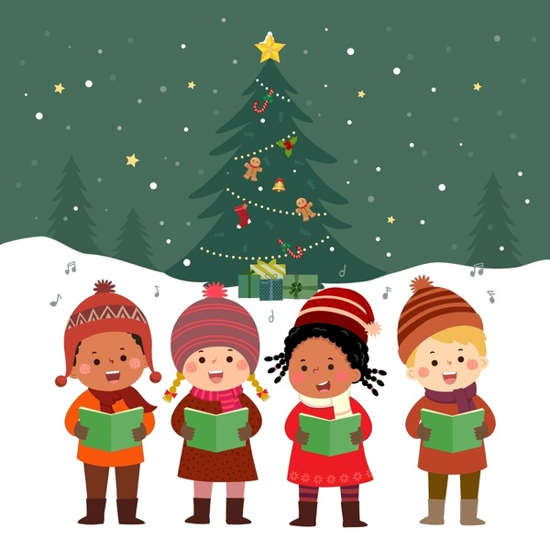

***Reminders:***

***December 12, 2024- We are going to Billy Bees!***

***12/13/23- Parent Teacher conference. I am requesting to meet with all parents.***

***12/20-Class Holiday Pajama Party (Grinch Theme)***



**Math: During the month of December K-1st grade will be working on number partners for 10, understanding teen numbers, and adding three numbers.**

**2nd Grade students will focus on adding and subtracting multi digit numbers with and without regrouping.**

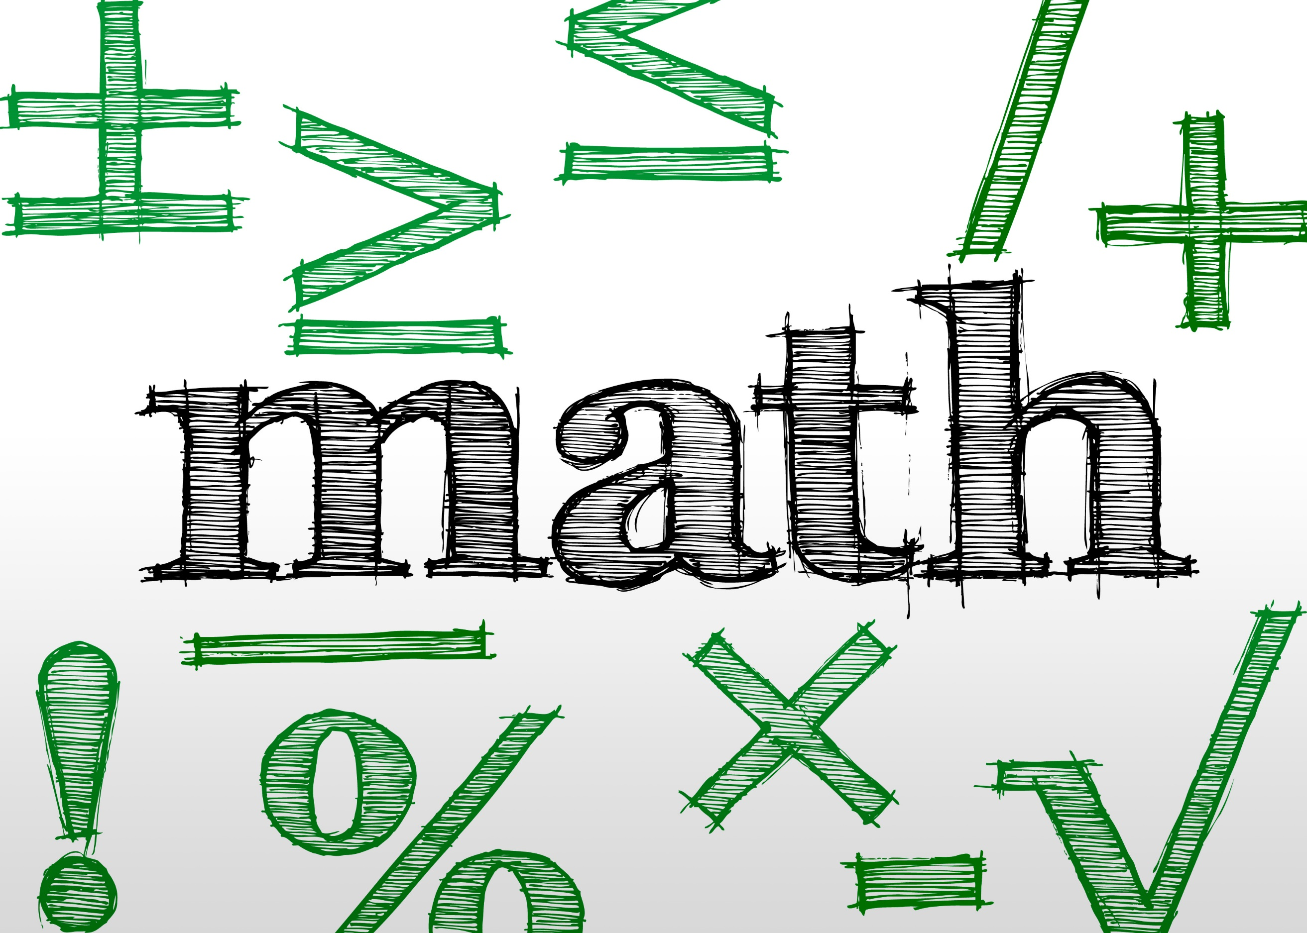

**Science: This month we will be learning all the holiday seasons’ most popular animal: Reindeer (Caribou, White-Tailed Deer, Elk and Moose.**

